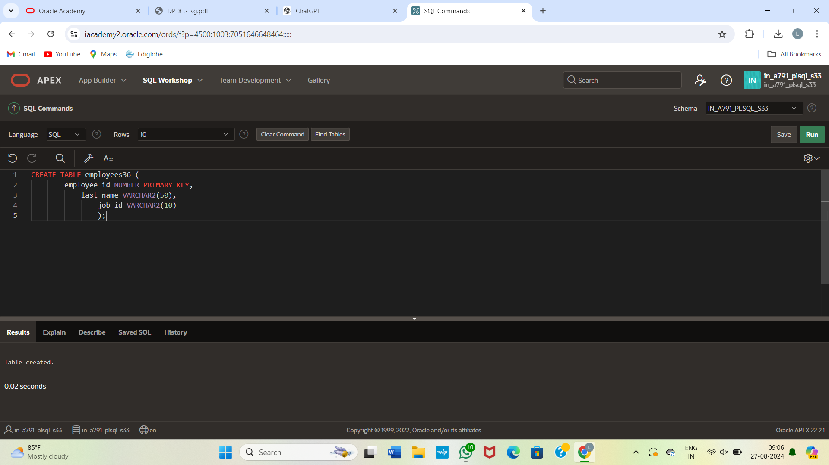

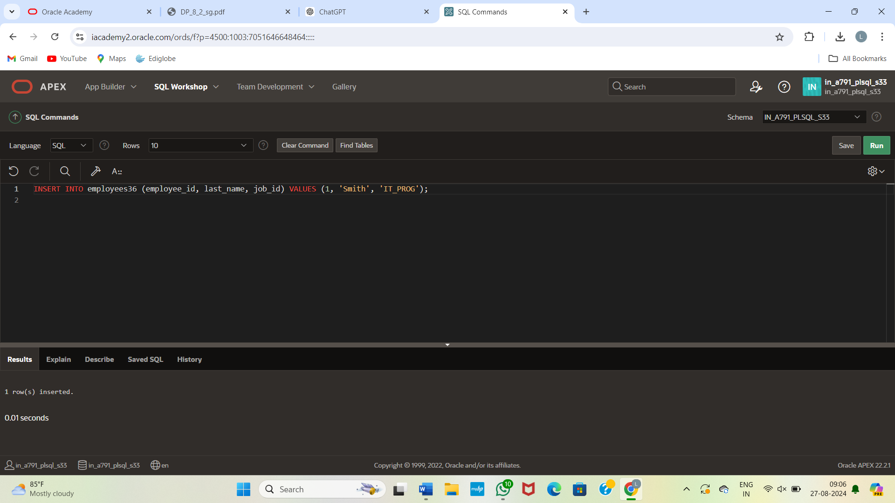

CREATE TABLE employees (

employee_id NUMBER PRIMARY KEY,

last_name VARCHAR2(50),

job_id VARCHAR2(10)

);

-- Insert sample data

INSERT INTO employees (employee_id, last_name, job_id) VALUES (1, 'Smith', 'IT_PROG');

INSERT INTO employees (employee_id, last_name, job_id) VALUES (2, 'Johnson', 'HR_REP');

INSERT INTO employees (employee_id, last_name, job_id) VALUES (3, 'Williams', 'IT_PROG');

INSERT INTO employees (employee_id, last_name, job_id) VALUES (4, 'Brown', 'FIN_MGR');

INSERT INTO employees (employee_id, last_name, job_id) VALUES (5, 'Davis', 'HR_REP');

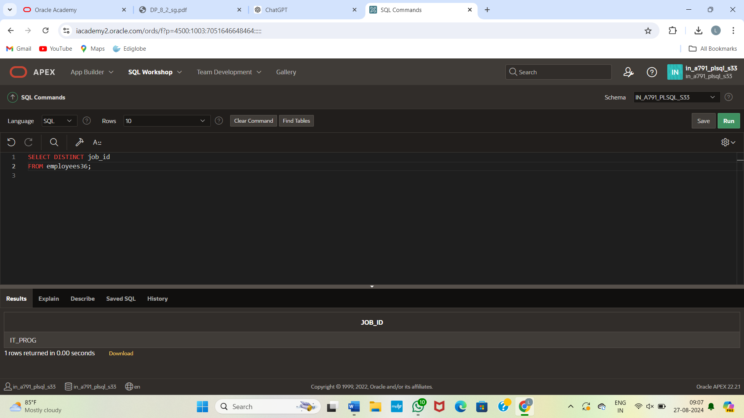

SELECT DISTINCT job_id

FROM employees;